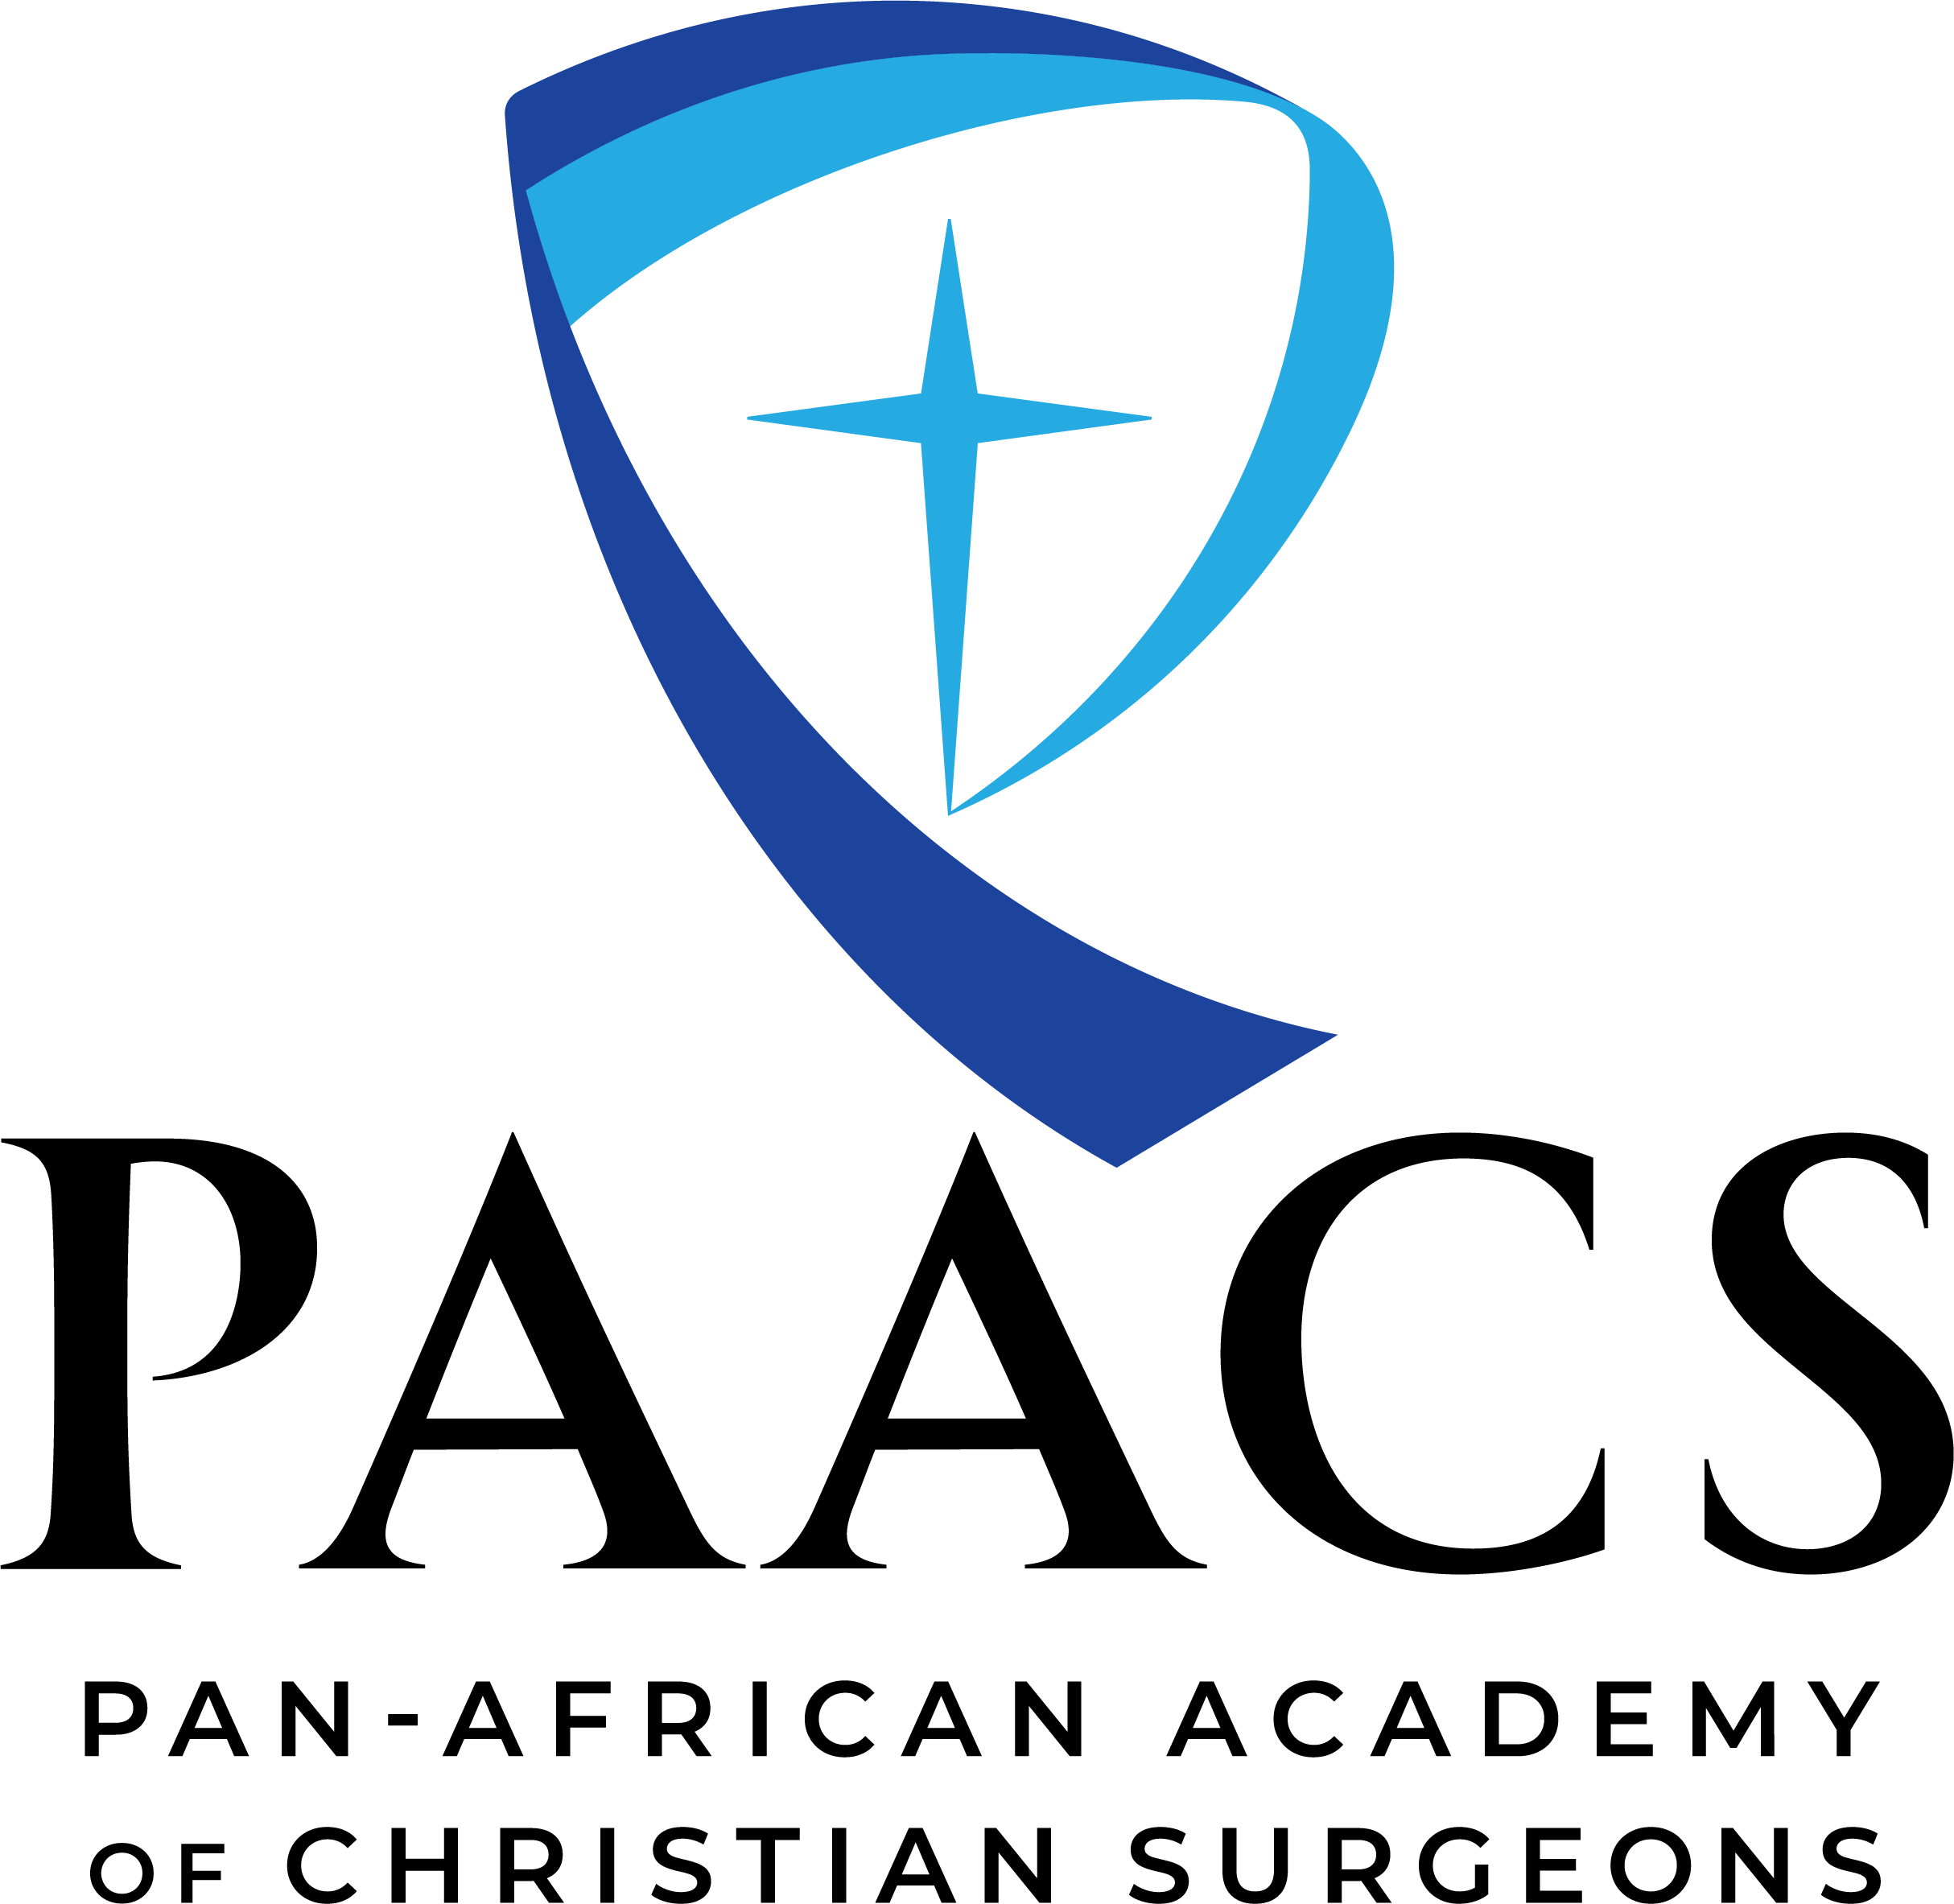

www.paacs.net

PAACS TRAINEE APPLICATION

Please e-mail this completed application and scans of all requested documents by April 15 to: admissions@paacs.net.
Upon receipt of this application there will be more materials requested which are due by May 15.
Please send this application only ONCE.

Please note: If you are over 35 years old, your chances of being accepted into a PAACS program will be considerably less than for younger candidates, but you may complete the process of applying to PAACS if you wish. If you are over 40 years old, we regret that we will not be able to process your application.

Instructions: Move from gray blank to blank using the tab key. If there is a box, click to select “x” to signify the correct answer.
If there is a rectangle, then type or print your answer in that rectangle. If you are unable to complete this electronically, you may print, complete, scan and email the document.

GENERAL INFORMATION
Full Name:  (SURNAME (Grandfather’s), First Name, Middle (Father’s), Other) | Date of Birth:
Name you go by: | Gender/Sex: Male Female
Mailing or Street Address: | Nationality:
Phone number(s) (include country code): | Religion:
E-mail: | Date of Marriage:

Languages in which you are fluent (list all):

Spouse’s Name: Date of Birth:
Child’s Name: Date of Birth: Adopted
Child’s Name: Date of Birth: Adopted
Child’s Name: Date of Birth: Adopted
Child’s Name: Date of Birth: Adopted
Child’s Name: Date of Birth: Adopted

ACADEMIC HISTORY
Dates School or University Name and Address Diploma Received
From to
From to
From to
From to
From to
From to

Formal Medical Training After Medical School:
Dates Hospital Name and Address Certification
From to
From to
From to
From to

Employment Since Graduation:
Dates Name and Address Position Held
From to
From to
From to
From to

Do you have any obligations to any organization (hospital, a government, church, military, mission agency, etc.) that you are required to complete either currently or at some date in the future? Yes No If you answered yes, please provide a description of any obligation (attach supporting documents if any).

Your Selection of Residency Program Preferences

I am applying for General Surgery: Yes, check the boxes of the programs you are willing to attend if selected.
No, skip to Subspecialty Programs or Post Fellowship Training

General Surgery Programs (5 year program)
VERY IMPORTANT: Only check “Yes” for programs that you are interested and WILLING to attend if you are selected by that program. If you are NOT WILLING to attend a specific program, check “No”.

Centro Evangélico de Medicina do Lubango (Angola) Yes No
Kibuye Hope Hospital (Burundi) Yes No
Mbingo Baptist Hospital (Cameroon) Yes No
Harpur Memorial Hospital (Egypt) Egyptian Nationality Only Yes No
Soddo Christian Hospital (Ethiopia) Ethiopian Nationality Only Yes No
Bongolo Hospital (Gabon) Yes No
Kijabe Hospital (Kenya) Yes No
Litein Hospital (Kenya) Yes No
Tenwek Hospital (Kenya) Yes No
Hopitaly Vaovao Mahafaly Mandritsara (Madagascar) Yes No
Malamulo Adventist Hospital (Malawi) Yes No
Nkhoma Mission Hospital (Malawi) Yes No
Galmi Hospital (Niger) Yes No
Arusha Lutheran Medical Centre (Tanzania) Yes No
Hospital of Hope (Togo) / Hôpital Baptiste Biblique (Togo) Yes No

Subspecialty Programs
I am applying for the Orthopaedic Residency (5 year program)
Soddo Christian Hospital (Ethiopia) Yes No
Kijabe Hospital (Kenya) Yes No
Tenwek Hospital (Kenya) Yes No
I am applying for the Pediatric Surgery Residency
BethanyKids/Kijabe Hospital (Kenya) Yes No
I am applying for Anesthesiology Training
Kijabe Hospital (Kenya) Yes No
I am applying for OBGYN Training
Tenwek Hospital (Kenya)
I am applying for Surgical Endoscopy Training
Tenwek Hospital (Kenya)
I am applying for Neurosurgery Training
Tenwek Hospital (Kenya) Yes No

Continued next page

Post Fellowship Training (General Surgery Diploma Required)
I am applying for the Cardiothoracic Surgery Fellowship (3 year program)
Tenwek Hospital (Kenya) Yes No
I am applying for the Head and Neck Fellowship (1 year program)
Mbingo Baptist Hospital (Cameroon) Yes No
I am applying for the Plastic Surgery Fellowship (3 year program)
AIC Kijabe Hospital (Kenya) Yes No

I have asked my hospital, church, or other institution to financially support me during my surgical training. Yes No Their response was

Please accept my application to become a trainee with PAACS. I hereby certify that I am in good health and that the statements in the Health Certificate Form I completed are true. I hereby certify that all information I have provided is correct to the best of my knowledge and belief.

Your Printed Name: Date of Application:

ADDITIONAL REQUIREMENTS

Your application must include the following to be complete:
- Copy of Birth Certificate
- Copy of Current Passport and/or Government ID
- Copy of Medical Diploma
- Copy of Medical License and evidence that it is current
- If Married, Copy of Marriage License
- Completed PAACS Health Certificate
- Transcripts from Medical School, Post Graduate, Master Exam
- Good Quality, Passport Style, Digital Color Photograph (scanned, attached to an email or mailed)

You are responsible to translate all documents which are not in English into English, and to have them notarized.
All required forms and documents must be submitted before May 15 of the current year in order to be considered for January of the following year.

Once the above information is completed, you will be notified by e-mail of the status of your application and any need for further documents before you are scheduled for one or more interviews with the PAACS faculty. Following your interview, your acceptance or rejection by the PAACS faculty will be final and is not subject to appeal.

Please e-mail this completed application and scans of all requested documents by April 15 to: admissions@paacs.net.
Upon receipt of this application there will be more materials requested which are due by May 15.

The Pan-African Academy of Christian Surgeons (PAACS)

_______________________________________________________________________________________________

FOR APPLICANT’S USE ONLY

Please keep a list of dates as you e-mail documents to PAACS. The deadline for having all your information (this application and subsequent materials) to PAACS is May 15. You are strongly encouraged not to wait until the last minute to get this information to us as it often takes several months to obtain it.

Send the completed list to admissions@paacs.net. This will assist both you and PAACS in making sure that all documents are received by the appropriate deadline.

Document | Date e-mailed to PAACS
Birth Certificate
Passport or Government ID
Medical Diploma
Medical License
Marriage License
PAACS Health Certificate
Transcripts from Medical School, Post Graduate, Master Exam
Color Photo

